Principio del formulario
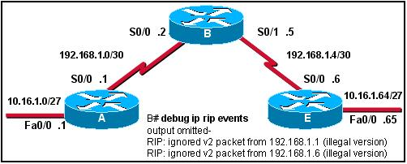
Refer to the exhibit. The exhibit shows partial results from the debug ip rip events command on router B. What is the likely cause of the debug messages?
 | Routers A and E are sending malformed updates.
 | RIP configuration on router B does not include networks connected to the serial interfaces.
 | Router B serial interfaces are not configured correctly.
 | Router B is running a different version of RIP than A and E.

2 | Principio del formulario
  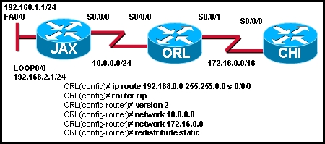
  Refer to the exhibit. All routers are running RIP version 2. JAX is configured to just advertise the 10.0.0.0/24 network. CHI is configured to advertise the 172.16.0.0/16 network. A network administrator enters the commands shown in the exhibit. What changes will occur in this network?
  The JAX router will ignore updates for the 172.16.0.0/16 network due to split horizon issues.
  The CHI router will install a route to the 192.168.0.0/16 network in its routing table.
  The routing table for CHI will have the 192.168.0.0/16 route but it will have an S next to the route.
  The ORL router will apply a 255.255.0.0 subnet mask to all networks in the routing updates it forwards.

3 | Principio del formulario
  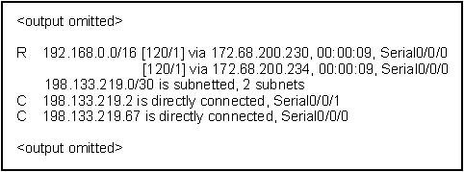
  Refer to the exhibit. Which statement correctly explains this output?
  There is a routing loop on the Serial0/0/0 and Serial0/0/1 interfaces.
  The routing table is recieving conflicting information from two different interfaces.
  The route has been sumarized for the network 192.168.0.0/16.
  The route to network 192.168.0.0/16 is being load balanced on two interfaces.
4 | Principio del formulario
  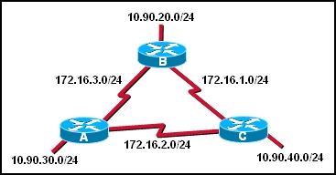
  RIP is configured as the routing protocol for the network shown in the graphic. The following commands are used on each router:
  router rip
  network 10.0.0.0
  network 172.16.0.0
  When this configuration is complete, users on the LAN of each router are unable to access the remote LANs. Why?
  RIP network statements are configured incorrectly.
  RIP has not installed all routes because updates have not completed.
  RIP is unable to route to discontiguous subnets of a major network.
  RIP is unable to route networks with a /24 subnet mask.

5 | Principio del formulario
  RIPv2 is the configured routing protocol on the routers in the network. The command no version is entered on the routers. What effect does entering this command have on the routing updates?
  Subnet masks will be added to the routing updates.
  Version 1 and 2 updates will be received and the version 2 updates will be ignored.
  Routing updates will be sent out using multicast address 224.0.0.9.
  The RIP routing process will be removed from the router and routing updates will not be created.
Principio del formulario
What are two functions of the network command used when configuring routing protocols? (Choose two.)
 | identifies which networks will be included in the routing updates
 | identifies the hosts addresses that can be summarized in the network
 | used to list all addresses for remote and local networks
 | determines which subnet mask to apply to routing updates
 | determines which interfaces can send and receive routing updates

7 | Principio del formulario
  What is the maximum network diameter permitted by the default metric of RIPv2?
  15 hops
  16 hops
  100 hops
  120 hops
  255 hops

8 | Principio del formulario
  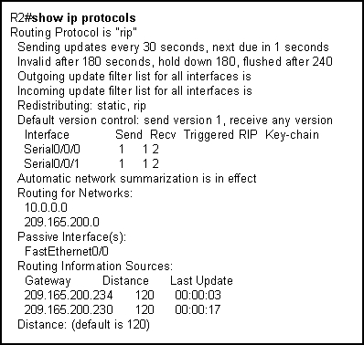
  Refer to the exhibit. What can be concluded from the output shown in the exhibit?
  The routing table is limited to 2 routes.
  The LAN interfaces are participating in the routing process.
  One update has been sent out of each serial interface and 2 have been received.
  The no auto-summary has not been configured on this router.
9 | Principio del formulario
  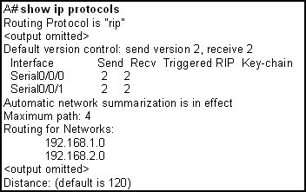
  Refer to the exhibit. The network administrator just connected a new router to router A. The administrator configured the new router for RIP and entered the network statements for its networks. The new router is seeing the updates from router A, but router A is not seeing the new router's networks. What could be the cause?
  The interface connecting one of the routers has a status of down or the protocol is down.
  Router A is configured for RIP version 2 and the new one is configured for RIP version 1.
  The RIP timers are configured incorrectly.
  The new router is not a cisco router.

10 | Principio del formulario
  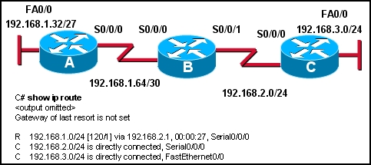
  Refer to the exhibit. If all routers are running RIP version 2, why is there no route for the 192.168.1.32/27 network?
  Rip version 2 does not send subnet masks in its updates.
  Router A is not setup with RIP as a routing protocol.
  Rip version 2 will auto summarize routes by default.
  Router B is not setup to advertise the 192.168.1.64/30 network.
Principio del formulario
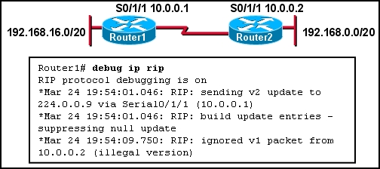
Refer to the exhibit. Which command on which router will allow Router1 to learn about the 192.168.0.0/20 network?
Router1(config)# ip classless
Router1(config-router)# no passive-interface serial 0/1/1
Router2(config-router)# version 2
Router2(config-router)# neighbor 10.0.0.2

12 | Principio del formulario
  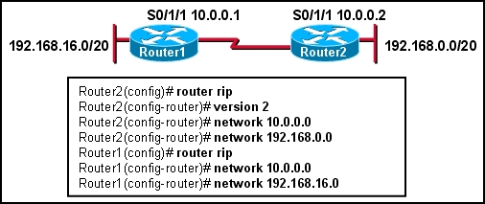
  Refer to the exhibit. Which two statements are true? (Choose two.)
  Router1 will install a route to 192.168.0.0/20
  Router1 will install a route to 192.168.0.0/24
  Router1 will install a route to 192.168.16.0/24
  Router2 will install a route to 192.168.16.0/24
  Router2 will not install a route to 192.168.16.0/20

13 | Principio del formulario
  How are RIP v1 and RIP v2 similar to one another? (Choose three.)
  They both use hop count as a metric.
  They both have the same metric value for infinite distance.
  They both broadcast their updates to their neighbors.
  They both send subnet mask information in their updates.
  They both provide for authentication of update sources.
  They both use split horizon to prevent routing loops.
14 | Principio del formulario
  What are two reasons to implement RIP version 2 rather than RIP version 1? (Choose two.)
  RIP version 2 supports VLSM.
  RIP version 2 supports more than 16 routers.
  RIP version 2 supports classful (and not classless) routing
  RIP version 2 supports routing update authentication.
  RIP version 2 supports multi-areas.
  RIP version 2 uses the Dijkstra algorithm rather than the Bellman-Ford algorithm.

15 | Principio del formulario
  Which of the following statements are true regarding RIP v1 and v2? (Choose three.)
  Both RIP versions use hop count.
  Both RIP versions can provide authentication of update sources.
  Both RIP versions use 16 hops as a metric for infinite distance.
  RIP v1 uses split horizon to prevent routing loops while RIP v2 does not.
  RIP v1 uses hold-down times to prevent routing loops while RIP v2 does not.
  RIP v1 broadcasts routing table updates, while RIP v2 multicasts its updates.
Principio del formulario
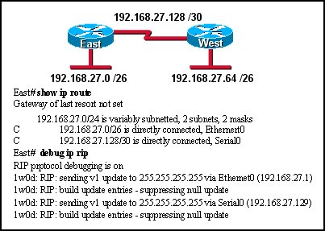
Refer to the exhibit. Routers East and West are configured using RIPv1. Both routers are sending updates about their directly connected routes. The East router can ping the West router serial interface and West can ping the serial interface of East. However, neither router has dynamically learned routes from the other. What is most likely the problem?
A gateway of last resort is required.
Subnetting is not supported by RIPv1.
VLSM is not supported by RIPv1.
One of the routers needs a clock rate on the serial interface.

17 | Principio del formulario
  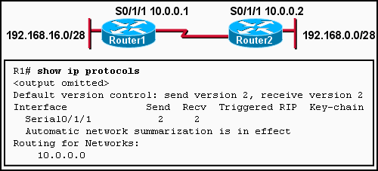
  Refer to the exhibit. Which command will allow Router2 to learn about the 192.168.16.0/28 network?
  Router1(config)# ip classless
  Router1(config-router)# network 192.168.16.0
  Router1(config-router)# no passive-interface serial 0/1/1
  Router2(config-router)# version 2
  Router2(config-router)# neighbor 10.0.0.2

